Good Dog! Vacations  220 Village Lane  Sciota, PA 18354-0245 | 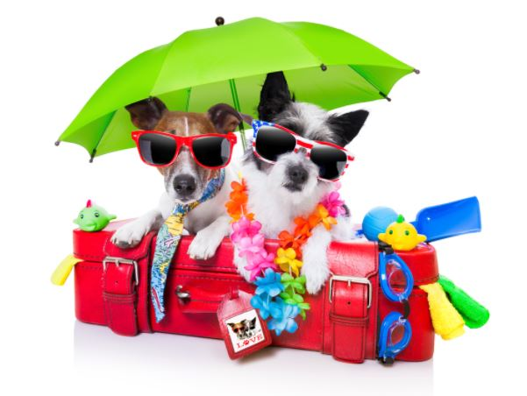
Visitor’s Name(s):

Good Dog! Pet Waiver
Dog’s Name(s):

Please read each item carefully and check the appropriate box. Incomplete forms will not be accepted, and may result in your reservation being rescheduled or cancelled.

As a responsible pet owner, I acknowledge that I am solely responsible for managing my pet during our visit and that I am solely responsible for any damage, harm or loss to Big Valley Resort or any other person or animal caused by my pet or in any way arising out of my pet’s visit.

- I Agree
- I Do Not Agree

My pet is up-to-date on all vaccinations, healthy, free of illness, and has not been in the presence of any contagious disease/illness/condition, or ill with any communicable disease/illness/condition, within the past 6 months.

- I Agree
- I Do Not Agree

I certify that my pet has not harmed or shown aggression or threatening behavior toward any person or other animal.

- I Agree
- I Do Not Agree

By signing this waiver, I knowingly and fully release, indemnify, defend and save harmless Big Valley Resort, its officers, directors, employees, agents, contractors, subcontractors, insurers, and representatives of and from any and all claims, damages and losses including, but not limited to, any and all claims for injury and/or death, loss of or damage to property, and all other losses suffered by Big Valley Resort, myself, and/or any other third party which may in any way relate directly or indirectly to my pet, irrespective of any negligence or other fault of Big Valley Resort, its employees, agents, contractors or any party whatsoever.

- I Agree
- I Do Not Agree

Signature Date

